Tett Centre for Creativity & Learning
A welcoming destination where artists, arts organizations, and the community come together to explore, create, and be inspired.

Call for Applicants
“The Creativity Studios”
‘Studio G or A’

February 11th, 2019: Issue Date
Ongoing: Submission Deadline
March 1st, 2019: Earliest Occupancy

For More Info: arts@tettcentre.org 343-266-0009-3091

Summary

The Tett Centre for Creativity and Learning at 370 King Street West, Kingston, Ontario is currently accepting proposals from arts professionals to rent one of the 8 Creativity Studios housed in The Tett.

These bright spaces, located in a historic building on the shores of Lake Ontario are available on one-year renewable leases at affordable rates. Artists at all stages of their careers and from all disciplines who commit to a program of community engagement and who meet the criteria are encouraged to submit proposals.

Mandate

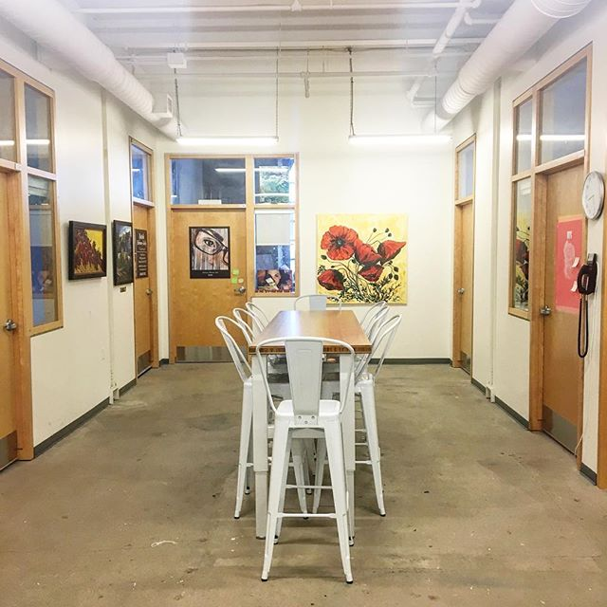
The Tett Centre for Creativity and Learning is a Not-for-Profit, charitable organization that operates an historic city-owned building on Kingston’s waterfront. We provide professionally equipped and affordable space to artists and arts organizations for artistic creation.
We are home to eight tenant arts organizations, eight resident artist studios, and four multi-use rentable public spaces. We are a dynamic arts hub that coordinates and creates high-quality, accessible, arts-focused programming for all levels of artistic abilities and experience.
Our partners include artists, arts and community organizations, The Isabel Bader Centre for the Performing Arts, and the City of Kingston’s Department of Cultural Services.
As a unique cultural landmark for Kingston residents and area visitors, we enhance learning and public participation in the arts.

Creativity Studios

It is our vision that The Creativity Studios will fill a need in the Kingston and the broader arts community for affordable, high quality, community-based arts studios that support our mandate. Tenants will have affordable access to studio space, including marketing on the Tett website, public exposure, and a beautiful studio in a vibrant arts community. In exchange, tenants will be required to take part in the larger Tett community by offering activities such as workshops, mentorships, skills development, installations, curating, community classes and events. This time will be referred to as the “Community Engagement Contribution” (CEC). Your application to the Creativity Studios will describe how you plan to contribute to the vision of the Tett, as well as providing a description of your past community arts experiences. Tenants will work with the Marketing & Programming Coordinator to develop these activities and integrate them into the broader artistic programming of the Tett. This opportunity to give back to the community will be an exciting and integral part of The Tett and its presence in Kingston and beyond. Those who prefer to pay *additional rent in place of the CEC must indicate this on their application, rent will be increased by *$75.00 per month.

-A mix of arts disciplines will be encouraged.
- Renewable 1 year licenses available.
-Please note, for those interested, The Tett Centre for Creativity & Learning provides monthly paid opportunities for resident artists.
-Artists will have unlimited building access, respecting quiet hours between 11:00pm and 7:00 am.
-The Tett Centre will be open to the public daily on published hours. Doors to the individual studios will be glass with blinds for privacy as required.
-The Tett will be host to numerous events throughout the year and will be a hive of creative activity. Artists can expect daily visitors to the centre, weddings, conferences, rehearsals, festivals, summer arts camps, city wide satellite events and events held in conjunction with our partners and community renters.
-Each space may accommodate 1 artist or a collective of no more than 2 artists (each artist must apply individually and make note of the intent to share).
-As part of their lease artists will be required to adhere to a tenant charter that outlines expectations of participation in facility activities as a whole.
-Artists must have a non-toxic arts practice.
- Artists will be expected to use the space primarily for art creation. For private instruction group sizes must adhere to fire regulations, and Creativity Studio Artists must receive prior approval from Tett Staff to run classes.
- An activity space is available to rent for workshops and classes at the tenant’s rate.
-An artist may sub-lease their studio while away, with permission of the selection committee. 2 months must be given in writing.
-Artists who are not selected at this time and who qualify, will be placed on a priority waiting list, if requested.

Space Descriptions

- 8 Artist Studios.
- All studios have 12’ceilings, at least one exposed limestone wall, with remaining walls of painted drywall, exposed utility services, and wiring for data services (arranged separately) in each suite.
- The Tett is completely accessible with barrier free parking, elevator access and washrooms.
- Double wide loading doors are located on the 2nd floor corridor
- Studios are located on the south end of the 2nd floor overlooking the lake. Each studio will have an open-able window – some studios have a low deep sill suitable for a window seat – with views of the lake.
- A central clean up area (with sediment traps) and coffee area
- Public display space is available both within the suite of studios as well as a public hallway space.
- Signage at the front of the building will notify visitors of the Studios and artists.
- Spaces are not sound proof. List of sizes (all sizes are approximate)
- Artists will attend a website training session and agree to keep their Tett webpage information current. Artists will upload events and workshops to the Tett calendar and notify the Marketing & Programming Coordinator of upcoming events or workshops associated to their CEC.

Studio |  | Size | sq f | t | CEC |  | Base Rate
A – Available |  | 10’ X 14’ | 141 |  | 2.5hrs/month |  | $384 + HST
B |  | 10’ X 14’ | 141 |  | 2.5hrs/month |  | $384 + HST
C |  | 14’ X 17’ | 236 |  | 2.5hrs/month |  | $599 + HST
D |  | 13’ X 11’6” | 152 |  | 2.5hrs/month |  | $415 + HST
E |  | 14’ X 17” | 236 |  | 2.5hrs/month |  | $599 + HST
F |  | 13’ X 12’6” | 175 |  | 2.5hrs/month |  | $465 + HST
G - Available |  | 12’ X 17’ | 214 |  | 2.5hrs/month |  | $552 + HST
H |  | 12’ X 17’ | 217 |  | 2.5hrs/month |  | $552 + HST

Artist Criteria

The Tett is dedicated to working with professional artists in all stages of their careers and therefore will consider applicants who are considered emerging at the time of their application.

A professional artist is someone who:
- has specialized training in the field (not necessarily in academic institutions),
- is recognized as such by peers (artists working in the same artistic tradition),
- has a history of public presentation or publication and community involvement.

NOTE: Applicants do not have to meet all the criteria in order to be considered a professional artist; however, The Tett Artist Advisory Committee members use the criteria as a guide to determine eligibility. Candidates may be asked to attend an interview.

What we are looking for:
- a completed Creativity Studio Application Form,
- a clear proposal which gives a good description of the artist’s intent to be involved in the Tett and the greater community,
- 3 reference letters from arts professionals, mentors, teachers or peers.

How to Submit a Proposal

Please send your e-mail application in PDF format to Nadine Baker, Facility Manager at facilitymanager@tettcentre.org. Creativity Studio Application should be in the subject field. For questions please email: Danielle Folkerts, Marketing & Programming Coordinator at arts@tettcentre.org

Supporting Documents

- A professional artist CV.
- 6-10 high resolution images of your art works with a corresponding details chart, for example: title, size and medium, description and date. Or links to online images or audio/visual work. Electronic submissions are preferred.

The Tett Centre for Creativity and Learning, throughout its business and administrative operations, is committed to protecting the privacy of individuals, groups and organizations.

Creativity Studios Application Form

- Name:
*If more than one artist is interested in the studio please complete a separate form for each artist and make note of the collective.
☐ Proposed collective, sharing with:

- Address:

- Phone:

- E-mail:

- Website:

- Arts discipline:

- Short Artist Bio. Please attach. Maximum 100 words.

- Artist CV. Please attach.

- Space Requested: ______

- A. How will you use your Creativity Studio? Please attach. Maximum 200 words.

  - How would you like to give back to the Tett Community for 2.5 hours? For example: workshops, classes, presentations. Be creative and think outside the box. Please include how you may have been involved in community art in the past. Please attach. Maximum 200 words.

  - OR additional rent amount up to $75.00/month:_______

- 3 reference letters. For example, from arts professionals, mentors, teachers or peers. *Successful applicants will be required to provide a CPIC (police check) for work with vulnerable populations.

- If you are chosen, when are you available to move in?
Signature __________________________ Date: __________

Please send your e-mail application in PDF format to: Facility Manager – facilitymanager@tettcentre.org. Creativity Studio Application should be in the subject field. For questions please e-mail: arts@tettcentre.org

